Tab 2
SECURE HOUSE
secure-house.co.uk

SEO PAGE CONTENT
Three New Product Pages — Ready to Publish
PAGE 1  Curved Glass Doors  SV: 70/mo | PAGE 2  Arch Doors  SV: 260/mo | PAGE 3  Stained Glass Doors  SV: 210/mo

PAGE 1: CURVED GLASS DOORS
URL: /doors/curved-glass-doors/ | Search Volume: 70/mo

Meta Data
Title Tag | Curved Glass Doors | Made to Measure & Secure Design
Meta Description | Made-to-measure curved glass doors, manufactured in the UK. Stunning design with multi-point security as standard. Free consultation.
H1 | Curved Glass Doors — Made to Measure, UK Manufactured & Security Certified
URL Slug | /doors/curved-glass-doors/
Primary Keyword | Curved Glass Doors
Secondary Keywords | Curved glass front doors UK, made-to-measure curved glass doors, curved glazed security doors, custom curved glass doors UK

Curved Glass Doors — Made to Measure, UK Manufactured & Security Certified

Curved Glass Doors
Few architectural features make a statement quite like a curved glass door. Whether you are designing a striking residential entrance, a contemporary extension, or a high-end commercial facade, curved glass doors deliver a visual impact that standard doors simply cannot match.
At Secure House, we design and manufacture curved glass doors from our UK facility in Luton — combining the elegance of architectural glazing with the robust, multi-point security systems we are known for. Every door is built to your exact measurements, your specification, your vision.
[ Get a Free Consultation ] [ Call 02078594207 ]

What Are Curved Glass Doors?
Curved glass doors feature glass panels that have been precision-shaped into a gentle arc — either convex (curving outward) or concave (curving inward). Unlike standard flat-glass doors, they require careful engineering of both the glass unit and the door frame to achieve a perfect, weatherproof, weather-tight fit.
They are increasingly specified for:
• Luxury residential properties — as front doors, garden room entrances, or rear extensions opening onto a terrace
• Period and heritage properties — where a traditional arched or curved profile needs to be faithfully recreated
• Commercial buildings — hotels, offices, showrooms and retail spaces seeking a distinctive, high-impact entrance
At Secure House, every curved glass door we produce is engineered with the same security standards as our wider door range. You never have to choose between a stunning design and a
door that genuinely protects your property.

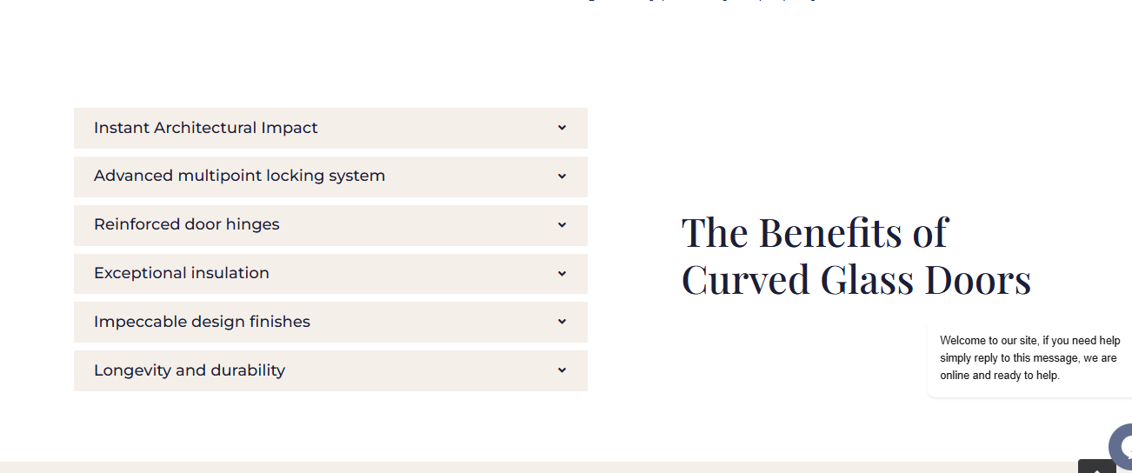

Change Background colour as given in the below reference

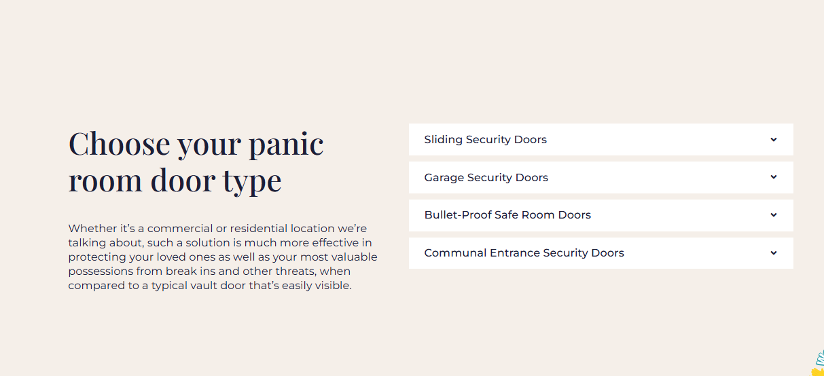
The Benefits of Curved Glass Doors

Instant Architectural Impact
A curved glass door sets a property apart immediately. The graceful arc creates a focal point that commands attention, adding kerb appeal and measurable value to any property.

More Natural Light Inside
Curved glass panels maximise the amount of natural light entering your hallway, living space or commercial entrance — creating a brighter, more welcoming atmosphere throughout the day.

Seamless Indoor-Outdoor Flow
For rear entrances and extensions, a curved glass door creates a fluid, uninterrupted connection between your interior and outdoor space — ideal for gardens, patios and terraces.

Built to Your Exact Dimensions
Every property is different. Our doors are manufactured to your precise opening dimensions and radius specifications — whether you need a subtle arc or a bold circular profile. No standard sizes, no compromise on fit.

Security Built In — Not Bolted On
Reinforced steel frames, 12-point multi-point locking, toughened safety glass and anti-drill plating are all standard. Striking design never comes at the cost of your security.

Key Features of Curved Glass Doors
- Bespoke UK manufacture — designed and built in our own factory to your exact specifications
- Available in a wide range of radii and configurations — from 2-panel to 6-panel curved sliding systems
- High-security multi-point locking systems integrated into the curved frame
- Thermally insulated aluminium frames — energy efficient and compliant with UK building regulations
- Toughened and laminated safety glass options, including Low-E glass for better thermal performance
- Smooth sliding or hinged operation — automation available for larger, heavier configurations
- Powder coated in any RAL colour — seamlessly matches your property exterior
- Suitable for both new-build projects and retrofit installations in existing properties
- Nationwide UK supply and installation coverage
Reference :-
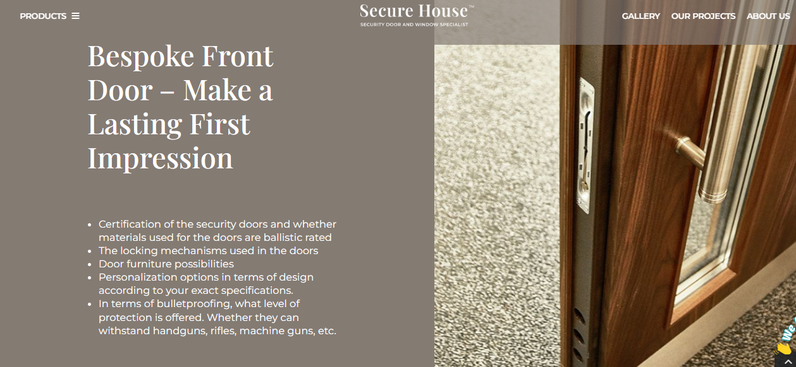

Where Are Curved Glass Doors Used?
Our curved glass doors are specified across a wide range of UK projects:
• Period and listed buildings — recreating original arched or curved entrances with modern security
• New-build luxury homes — creating a signature architectural entrance
• Rear kitchen and dining extensions — connecting interior living spaces to garden terraces
• Commercial showrooms and office lobbies — making a powerful first impression on visitors
• Hotels and hospitality venues — blending luxury aesthetics with practical security
• Garden rooms and orangeries — maximising glazing and natural light
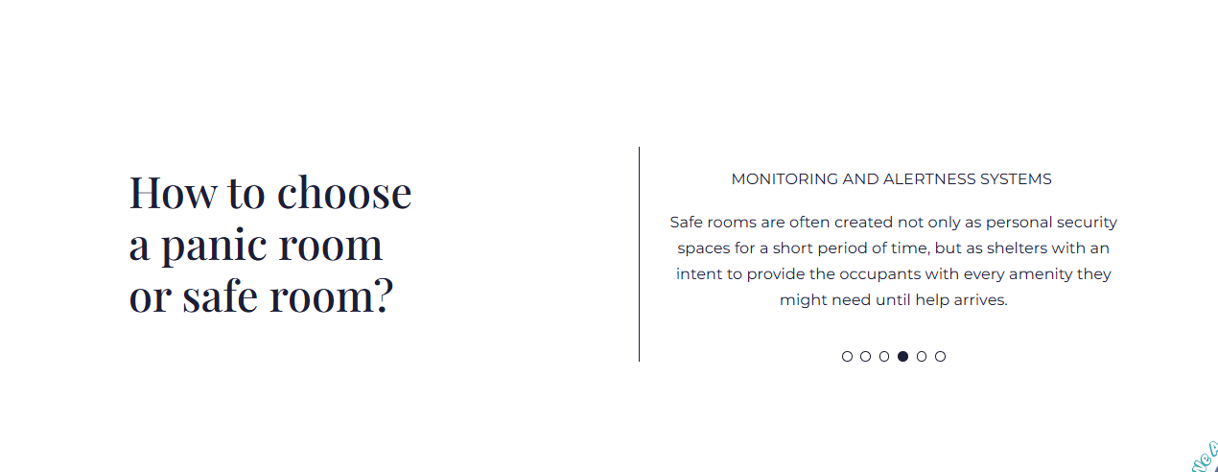

Curved Glass Doors — Frequently Asked Questions
Q: How much do curved glass doors cost in the UK?
A: Curved glass doors are a premium, made-to-measure product and pricing depends on size, radius, glazing specification and security features required. At Secure House, we provide a free, no-obligation quote tailored to your exact requirements. Contact us for a personalised consultation.
Q: Are curved glass doors secure?
A: Yes. All our curved glass doors are built with reinforced steel frames, 12-point multi-point locking and toughened safety glass as standard. Our doors are certified to EN 1627:2011 and PAS 24 — the same security standards across our full door range.
Q: Can curved glass doors be used as front doors?
A: Absolutely. A curved glass front door makes a stunning and highly secure entrance for residential and commercial properties alike. Each door is manufactured to your specific opening dimensions and radius.
Q: How long does it take to manufacture and install a curved glass door?
A: Lead times vary depending on specification and complexity. We will confirm a clear, agreed timeline during your consultation before any work begins.
Q: Do curved glass doors offer good insulation?
A: Yes. Our doors feature thermally broken frames and double glazing as standard, with triple-glazed options available — delivering excellent thermal and acoustic performance alongside their striking appearance.
Q: Can you fit a curved glass door to an existing opening?
A: Yes. Our team carries out a full site survey before manufacture to ensure your door is built to the precise dimensions of your existing opening for a perfect, weather-tight fit.
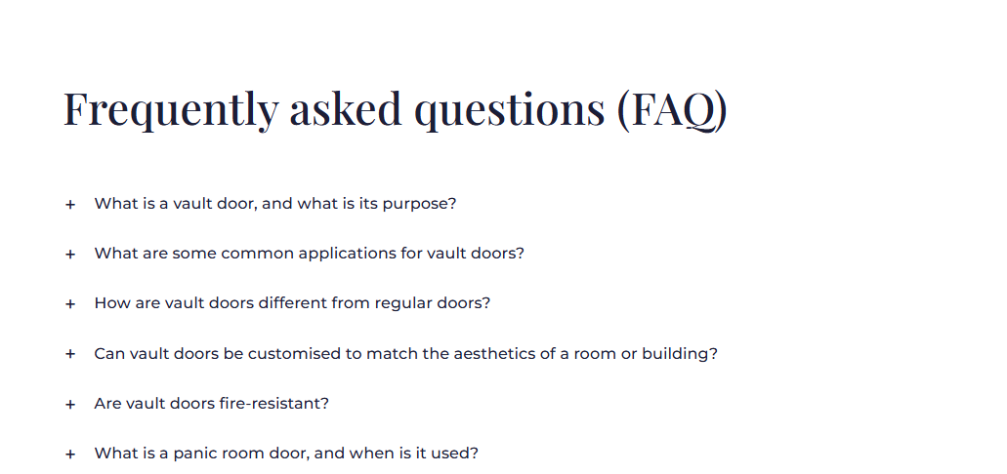

Internal Links to Include
• /doors/high-security-doors/ — anchor: "high-security door range"
• /doors/bespoke-doors/ — anchor: "view our full door range"
• /doors/ — anchor: "all door styles"
• /products/ — anchor: "explore all products"

PAGE 2: ARCH DOORS
URL: /doors/arch-doors/ | Search Volume: 260/mo

Meta Data
Title Tag | Arch Doors | Made to Measure Arched Front Doors UK
Meta Description | Custom-built arch doors, manufactured in the UK. Steel-reinforced arched front doors for period and modern properties. Security certified. Free consultation.
H1 | Arch Doors — Custom Built, UK Manufactured, Security Certified
URL Slug | /doors/arch-doors/
Primary Keyword | Arch Doors
Secondary Keywords | Arched front doors UK, made-to-measure arch doors, arched security doors, custom arch doors UK, round top doors UK, arched steel doors

Arch Doors — Custom Built, UK Manufactured, Security Certified

Arch Doors
An arch door does more than frame an entrance — it defines it. Whether you are restoring the character of a period property or creating a bold architectural focal point on a new build, a hand-built arched front door delivers a timeless elegance that no standard rectangular door can match.
At Secure House, we design and manufacture arch doors from our UK facility in Luton — every profile, every dimension, every finish built to your exact specification. Each door combines the classic proportions of an arched entrance with the high-security engineering that modern homes and commercial properties demand.
[ Get a Free Consultation ] [ Explore Arch Door Styles ]

What Is an Arch Door?
An arch door — also called a round-top door or arched front door — features a curved or rounded top profile rather than the flat header of a standard rectangular door. The most common arch profiles are:
• Semi-circular arch — a classic full half-circle head, widely seen on Georgian and Victorian properties
• Gothic or pointed arch — a distinctive V-shaped curve associated with period and ecclesiastical architecture
• Segmental arch — a subtle, flatter curve that adds elegance without the drama of a full semicircle
• Elliptical arch — a wider, oval-shaped curve popular in contemporary and Art Deco influenced properties
At Secure House, we build all arch door profiles — from a traditional semicircular Victorian arch to a sleek modern segmental curve — entirely to your specification, from the dimensions of your opening to the finish on the frame.

The Benefits of Arch Doors

Transforms Your Property's First Impression
Few design choices have a greater impact on kerb appeal than an arched front door. The sweeping profile signals craftsmanship and quality before a visitor has even crossed the threshold.

The Right Choice for Period Properties
Georgian, Victorian and Edwardian homes were designed around arched proportions. A properly built arch door restores authentic character to a period property — without compromising on modern security, insulation or energy efficiency.

A Growing Trend in Contemporary Architecture
The arch has made a strong return in modern residential design. A steel-framed, cleanly detailed arch door brings warmth and sculptural interest to an otherwise contemporary facade.

Built Precisely to Your Opening
No two arched openings are identical. Each door is manufactured to the precise dimensions of your specific opening — ensuring a perfect, draught-free, weather-tight fit from day one.

High Security Built In as Standard
Every arch door we produce includes our 12-point multi-point locking system, reinforced steel frame and anti-drill security plating. Strong design and genuine security are not a compromise — they come together in every door we build.

Materials, Profiles & Customisation

Steel-Framed Arch Doors
Our steel-framed arch doors offer outstanding structural strength. With frames of up to 115mm in thickness, they resist forced entry from crowbars, hammers and heavy-duty tools — while maintaining an elegant, refined appearance.

Glazing Options
Choose from clear, frosted, toughened, laminated, decorative or stained glass panels. Glazing can be incorporated into the arch head, side panels, or within the door leaf — or combined across all three for a fully glazed entrance.

Colours and Finishes
Available across the full RAL colour range, with powder coat, satin and gloss finish options. Timber-effect cladding is also available for properties where a warmer, more traditional look is required — without sacrificing the strength of a steel core.

Door Hardware
Hardware is chosen to suit your style — from period-inspired handles and knockers in brass, chrome or antique black, to contemporary lever handles and smart electronic locking systems.

Who Chooses Arch Doors?
Our arch doors are specified by a wide range of clients across the UK:
• Homeowners renovating or restoring a period property who want to match original architectural proportions
• Property developers working on high-end residential schemes who want to differentiate with strong architectural detail
• Architects and designers specifying premium entrance solutions for listed buildings or heritage-sensitive projects
• Commercial clients — hotels, restaurants, private members clubs — seeking an entrance that signals exclusivity
• New-build homeowners who want to introduce warmth and character to a clean, contemporary facade

Key Features Of Arch Doors
- Genuine bespoke manufacture — every arch door built to your exact measurements and design preferences
- Over 200 standard designs — or supply your own design prepared by an architect
- 12-point multi-point locking system — uncompromising security across all arch door variants
- Reinforced steel frames — from 100mm to 115mm thickness, resistant to crowbars, drills and impact
- Complete thermal insulation — up to 60mm rockwool for outstanding thermal and acoustic performance
- Full range of hardware — handles, knockers, letterboxes and furniture matched to your arch door style
- Available in any RAL colour — powder coated for long-lasting durability in the UK climate
- Fire-rated and bulletproof arch door options available on request
Hinged or pivot door options engineered for smooth, reliable operation

Arch Doors — Frequently Asked Questions
Q: What is the difference between an arch door and a standard front door?
A: An arch door features a curved or rounded top profile — semicircular, segmental or gothic — rather than the flat header of a standard rectangular door. This gives it a distinctive, architecturally rich appearance suited to both period and contemporary properties.
Q: Can you fit an arch door into an existing rectangular opening?
A: Yes. In most cases, an arched door frame can be installed into an existing rectangular opening, with the arched head formed within the new frame. Our team will assess your existing opening during a free site visit and advise on the best approach.
Q: Are arch doors secure?
A: Yes. Every arch door we build at Secure House includes a reinforced steel frame, 12-point multi-point locking, anti-drill manganese plating and toughened glass. All doors meet EN 1627:2011 and PAS 24 security standards.
Q: Do arch doors work on modern homes?
A: Absolutely. While arch doors have a strong heritage association, they are increasingly chosen for contemporary properties where architects and homeowners want to add sculptural warmth and character. We produce arch doors across all profiles to suit any architectural style.
Q: Can I add stained glass to an arch door?
A: Yes. We offer a full range of glazing options for arch doors, including decorative and stained glass panels — which can be set into the arch head, sidelights or within the door leaf itself.
Q: How long does it take to build and install an arch door?
A: Lead times depend on the specification and profile complexity. We will agree a clear, confirmed production and installation timeline with you before any work begins.

Internal Links to Include
• /doors/high-security-doors/ — anchor: "our high-security front doors"
• /doors/stained-glass-doors/ — anchor: "add stained glass to your arch door" (Page 3)
• /doors/bespoke-doors/ — anchor: "view our full range"
• /doors/ — anchor: "explore all door styles"

PAGE 3: STAINED GLASS DOORS
URL: /doors/stained-glass-doors/ | Search Volume: 210/mo

Meta Data
Title Tag | Stained Glass Doors | Victorian, Edwardian & Modern UK
Meta Description | Hand-designed stained glass doors for period and modern UK homes. Victorian, Edwardian and custom designs. Full security certified. Free consultation.
H1 | Stained Glass Doors — Hand Designed, UK Built & Security Certified
URL Slug | /doors/stained-glass-doors/
Primary Keyword | Stained Glass Doors / Stain Glass Doors
Secondary Keywords | Stained glass front doors UK, Victorian stained glass door, Edwardian glazed front doors, custom stained glass door panels, leaded glass front doors UK

Stained Glass Doors — Hand Designed, UK Built & Security Certified

Stained Glass Doors
Stained glass has graced the entrances of British homes for over 150 years — from the rich jewel tones of the Victorian era to the delicate florals of the Edwardian period. A stained glass front door is one of the most personal and characterful choices a homeowner can make for their property.
At Secure House, we combine this timeless craft with the security engineering that modern homes demand. Every stained glass door we build is designed to your exact specification — your choice of pattern, colour palette and glass style — manufactured at our UK facility and installed by our specialist team.
[ Get a Free Consultation ] [ Request a Custom Design ]

What Are Stained Glass Doors?
Stained glass doors feature decorative glass panels set within the door leaf, sidelights or transom — using coloured, leaded, etched or painted glass to create a design that filters and transforms natural light as it passes through the door.
The term 'stain glass doors' (also written as 'stained glass doors') covers a wide range of styles and techniques:
• Traditional leaded stained glass — individual pieces of coloured glass joined with lead caming, as seen in Victorian and Edwardian front doors across the UK
• Etched or sandblasted glass — designs carved or frosted into clear glass for a more subtle, contemporary effect
• Art Deco stained glass — bold geometric patterns in amber, blue and green, widely found in 1920s and 1930s properties
• Hand-painted or fired glass — entirely original designs, from family crests to abstract motifs, permanently fired into the glass surface
At Secure House, we produce stained glass panels to the highest standard — whether recreating an original period design or producing something completely new to your brief.

Period Stained Glass Styles We Build

Victorian Stained Glass Doors
Victorian stained glass typically features rich jewel colours — deep ruby, cobalt blue, emerald green and amber — arranged in bold geometric or floral compositions. A central pictorial panel surrounded by a decorative border is a hallmark of the style. We recreate these using hand-cut coloured glass, faithful to the original methods.

Edwardian Stained Glass Doors
Edwardian glazing favours softer, lighter tones — flowing florals, stylised leaves and gentle curves worked in clear and lightly tinted glass. The result is an airier, more refined look compared to the bold drama of Victorian work.

1930s Art Deco Stained Glass
The interwar period introduced bold angular geometry to British doorways — sunburst patterns, stepped borders and clean abstract forms in amber, green and black. Particularly sought-after for the millions of semi-detached homes built across the UK between the wars.

Original Custom Designs
Not limited to period styles. We work directly with homeowners, architects and interior designers to produce completely original stained glass designs for modern properties — built around your chosen colours, proportions and vision.

Security Is Never Compromised
One of the most common questions we receive is whether a glazed front door can be truly secure. The answer, when it is built correctly, is yes.
Every stained glass door we manufacture is built on the same high-security platform as our full security door range:
• Reinforced steel frame — structural integrity that cannot be undermined by the presence of decorative glazing
• 12-point multi-point locking system — with anti-drill manganese plate protection as standard
• Toughened or laminated safety glass — meeting all relevant British and European safety standards
• Optional interlayer laminated glass — holds together under impact, significantly raising resistance to forced entry through the glass panel
• EN 1627:2011 and PAS 24 certification — the same standards met by our steel security door range
A stained glass door from Secure House is as strong as it is beautiful.

Key Features Of Stained Glass Doors
- Authentic traditional appearance — visually identical to original Victorian and Edwardian leaded glass
- Modern toughened safety glass base — far stronger and safer than traditional fragile glass construction
- Available as single or double-glazed units — better thermal and acoustic performance
- Meets UK building regulations — compatible with Pilkington K Glass energy-saving specification
- Hundreds of design patterns available — or fully bespoke custom designs
- Computer-generated proof before production — see exactly how your panel will look
- Can be combined with high-security door bodies — beauty without sacrificing protection
- Nationwide UK delivery and installation — supply only or supply and fit available
- Replacement panel service — new stained glass panels for existing doors

Why Choose Secure House for Your Stained Glass Door?
There are many suppliers of decorative glazed doors in the UK. What sets Secure House apart is the rare combination of genuine craft and genuine security engineering — two things that rarely come together under one roof.
• UK manufactured — every door is built in-house at our Luton facility, not outsourced
• Security first — our foundations are in high-security door engineering; the decorative element never overrides the structural one
• Built to your opening — no standard sizes, no catalogue limitations; every door is made to fit your property
• Period expertise — we understand the architectural context and proportions of Victorian, Edwardian and Georgian properties
• Full service — design, manufacture, supply and installation handled by our own team from start to finish
• Trusted across the UK — chosen by homeowners, architects and developers on projects across the country

Stained Glass Doors — Frequently Asked Questions
Q: What is the difference between stained glass and leaded glass?
A: Leaded glass refers to the method of joining glass pieces using lead caming (strips of lead). Stained glass is coloured glass, which is usually also leaded. For traditional UK front doors, the two terms are commonly used to mean the same thing.
Q: Are stain glass doors (also called stained glass doors) secure?
A: Yes — when built correctly. At Secure House, all our stained glass doors include reinforced steel frames, 12-point multi-point locking and toughened or laminated safety glass. They are certified to EN 1627:2011 and PAS 24. Decorative glass panels do not reduce the security of the door when the door is engineered to the right standard.
Q: Can you replace a damaged stained glass panel?
A: Yes. If your existing stained glass door has a cracked, broken or missing panel, we can restore or replace it — recreating the original design as closely as possible from photographs or surviving sections.
Q: Can I have panels designed to match my existing windows?
A: Absolutely. We regularly produce stained glass panels that complement or continue existing glazing in fanlights, sidelights or internal windows within a property.
Q: Are stained glass doors energy efficient?
A: Yes. Our stained glass panels are set within double-glazed units with thermally broken frames — providing good energy performance alongside their decorative appeal. Triple glazing is available for properties with higher thermal requirements.
Q: Can stained glass be added to other door styles?
A: Yes. Stained glass panels can be incorporated into arch doors, standard front doors and other styles across our range. Discuss your requirements with our team and we will advise on the best configuration for your property.
Q: How long does it take to design and build a stained glass door?
A: Lead times vary depending on design complexity and current production schedule. We will give you a clear, confirmed timeline during your free consultation before any commitment is made.

Internal Links to Include
• /doors/arch-doors/ — anchor: "add stained glass to an arch door" (Page 2)
• /doors/high-security-doors/ — anchor: "our high-security door range"
• /doors/bespoke-doors/ — anchor: "view our full door range"
• /doors/ — anchor: "explore all door styles"
Pages Links

https://secure-house.co.uk/doors/curved-glass-doors/
https://secure-house.co.uk/doors/arch-doors/
https://secure-house.co.uk/doors/stained-glass-doors/

Tab 3

CROSS-PAGE SEO NOTES & RECOMMENDATIONS

1. Internal Linking Strategy
• Arch Doors page -> 'add stained glass panels' -> Stained Glass Doors page
• Curved Glass Doors page -> 'explore our full range' -> Bespoke Doors page
• All three new pages -> 'our security standards' -> High Security Doors page

2. Image Optimisation
• Hero images ALT text: primary keyword + 'UK' + descriptive detail (e.g. alt='Curved glass front door UK period property')
• Gallery images: describe style, material and setting (e.g. alt='Victorian stained glass front door London terrace')
• Compress all images to under 150KB without quality loss — critical for Core Web Vitals

3. Schema Markup
• FAQPage schema — add from the FAQ sections in this document via Yoast or RankMath
• Product schema — name, description, brand: Secure House, manufacturer, areaServed: UK
• LocalBusiness schema — already on site; ensure it links through to all new pages

4. Keyword Variant — 'Stain Glass Doors'
The FAQ question 'Are stain glass doors secure?' on Page 3 captures the exact misspelled variant. Google treats both as the same query and ranks the page for both — no separate page needed.

5. Suggested Supporting Blog Articles
These articles build page authority and create natural internal links to the new pages:
• 'Curved Glass Doors: Are They Right for Your UK Property?' -> links to Page 1
• 'How to Choose the Right Arch Profile for a Period Home' -> links to Page 2
• 'Victorian vs Edwardian Stained Glass: What Is the Difference?' -> links to Page 3
• 'The Complete Guide to Secure Front Doors for Listed Buildings' -> links to all three pages

